Shopping List
Most of these items can be found at www.petedge.com, www.entirelypets.com or www.carealotpets.com (Care-A-Lot is local to Hampton Roads, there are 3 stores in the area)... Or there is always AMAZON!

- Canidae Dog Food (All Life Stages) (www.canidae.com)
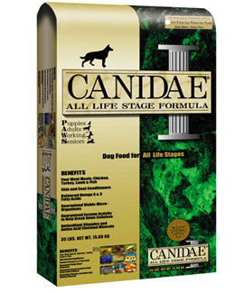
- Johnson & Jonhnsons Baby Shampoo (Use for puppies)
- Melaseb Shampoo (http://www.revivalanimal.com/store/p/714-Malaseb-Shampoo.aspx - BEST SHAMPOO EVER!)
- Advantix II for Fleas/Ticks
- Sentinel for HeartWorm Preventative
- 36” Midwest or Petmate FOLD DOWN style crate (you will need a divider until he/she is bigger – Midwest usually has them included)
- 36” primo pad (http://www.primopads.com/)
- Biscuits (cookies) any brand (I usually get the bulk or generic lil colored ones – use these to help with crate training)
- Bitter Apple Spray
- Leash & Collar (I recommend the ¾” combination collar made by Lupine, this is a martingale type / anti-slip collar, no buckle. This way you can keep the collar loose fitting, but can control them with the choke if needed. (Lupine guarantees their products for life, even if chewed www.lupinepet.com to find a store near you)
- Flexi leash & poop bags – I like the “tape type” Flexi
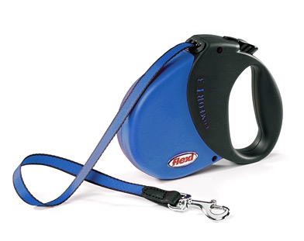
- Stainless steel bowls (2)
- 1 cup measuring cup (for measuring food)

- Hard Nylabones - They LOVE the keys (get the XL size)
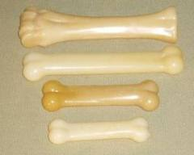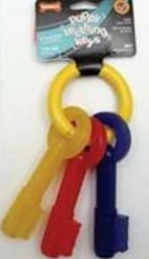

- Kong Brush (Zoom Groom)
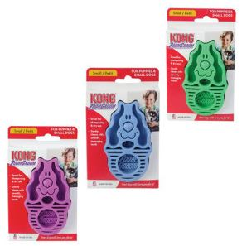

- Paper towels (for cleaning up accidents)
- Baby wipes (for wrinkles & bums)
- Benadryl (PLAIN - For allergies & anxieties – Dosage 1 mg per lb. - (1) 25 mg tab for puppies, (2) 25 mg tabs for adults)
- Vaseline (for dry nose)
- Cotton balls (for cleaning ears and for putting in ears when bathing)
- Vet Solution Ear Cleanser – AS NEEDED (http://www.revivalanimal.com/store/p/172-Vet-Solutions-Ear-Cleansing-Solution.aspx)
- Cordless Dremel (for nails)
- Natures Miracle – Cleaning solution – AWESOME for messes / smells on carpets!
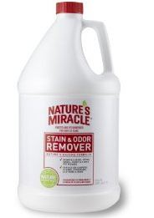

Toys!!!
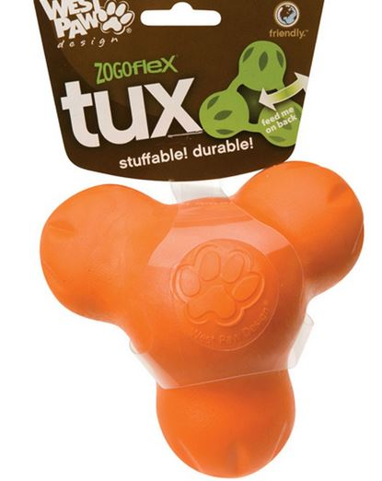
TUFF toys… http://www.dogtuff.com/
- WEST PAW ZOGOFLEX TUX – You can fill them with water & freeze for a frozen treat. Or fill will yogurt or peanut butter & freeze, or just a great chew toy!

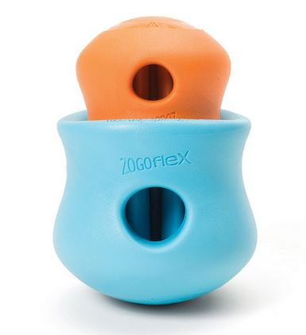
- WEST PAW ZOGOFLEX TOPPL TREAT TOY – Get both the small and large one! They will have fun trying to break them apart! Throw um for fetch fun! Put food in them and it’s a treat ball! Freeze it with yogurt or peanut butter for even more fun!

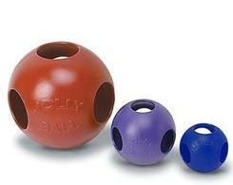
Jolly Pets Teaser Ball (I get the 8” size)

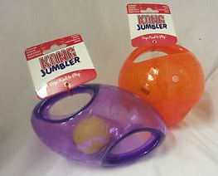
KONG Jumbler Ball (The medium (smaller size) ball is the fav around here, but I have all sizes! – They squeak and have a tennis ball inside!)

Jolly Pets Romp-n-Roll Ball (Hercules Fav)
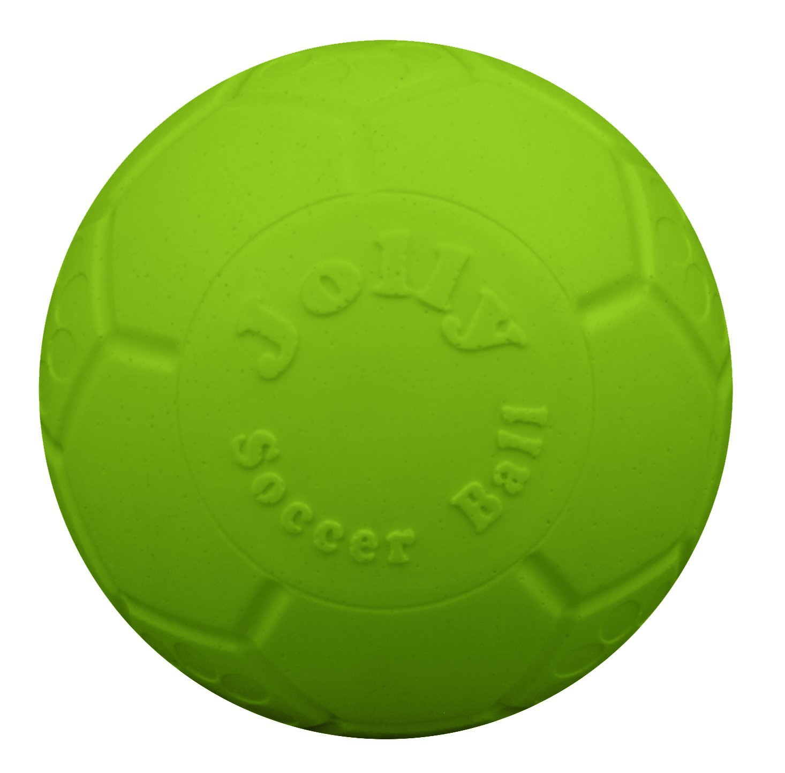
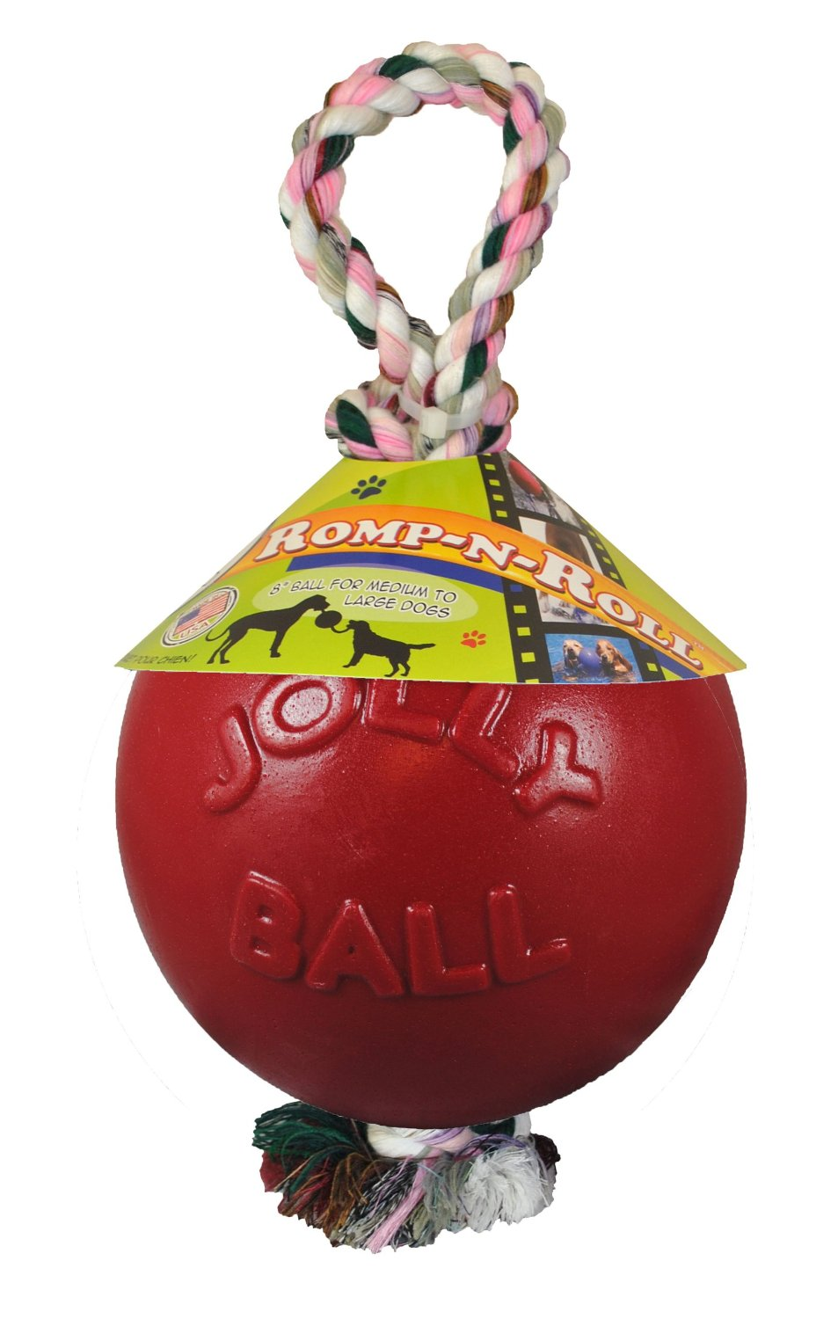

Jolly Pet 8" Soccer Ball (Marley Fav – Get the medium size)

Nerf Dog Soccer Squeak Ball Dog Toy, Large, Red (Everyone loves these and they hold up well – Avail on Amazon & Target – Get the LARGE size)
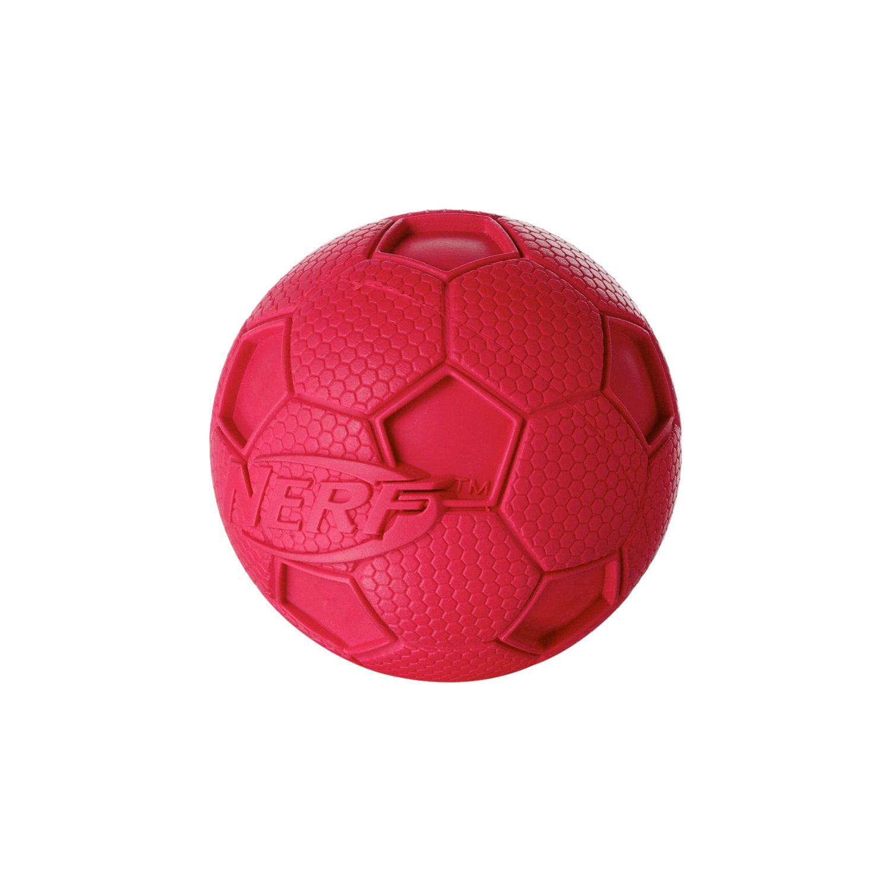
JW “Tough By Nature” Toys! Can’t go wrong here!! DNA Toy is a BIG fav!
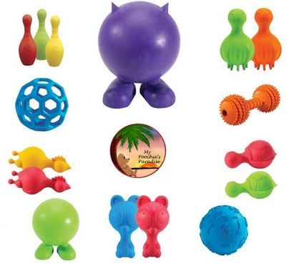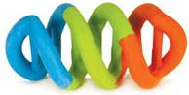

KONG Squeezz Jels (Mine LOVE the Med (smaller) size, Koala is the fav! – Durable Squeak!)
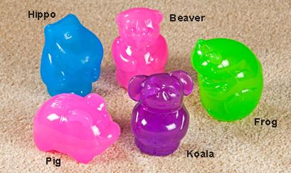

Marrow Bones / Knuckles (RedBarn is my fav brand, just make sure they are sterilized & made in USA! Butcher shop usually has nice FRESH bones too…)
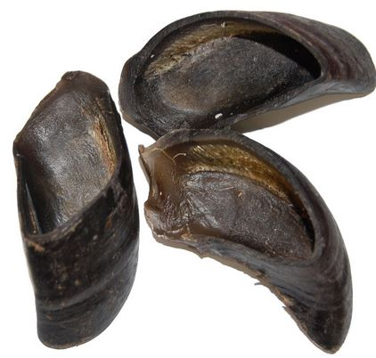
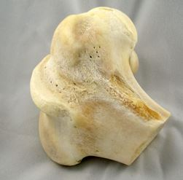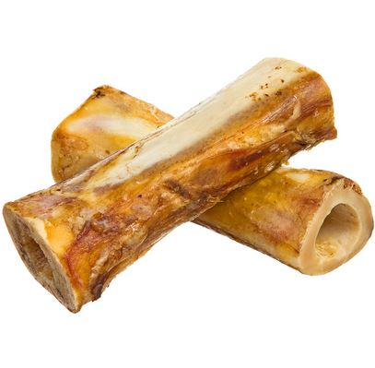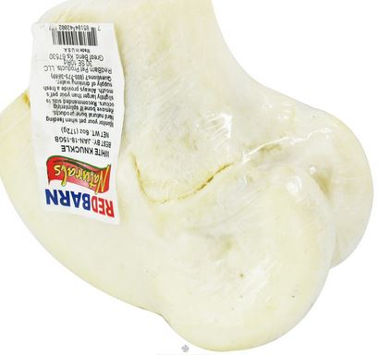

Hooves (any flavor / assortment… just throw them away when they get small)

Midwest Quiet Time Beds
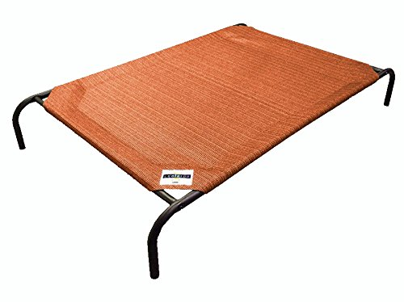
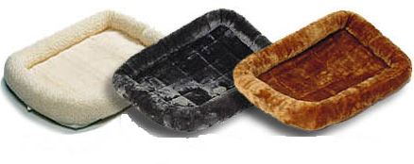
Coolaroo Elevated Pet Bed (Medium size) – Avail on Amazon
Perla Bed (very popular – 30” size Make sure you put some bedding / blankets in it… )
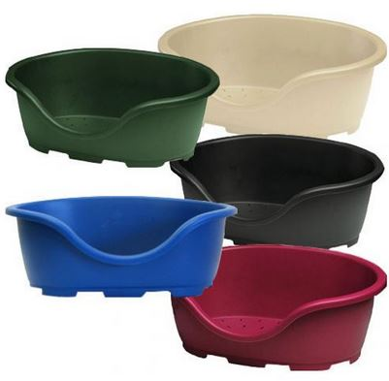

PURE Pumpkin in a can (Not the pie mix, PURE… Use for constipation / diarrhea –FIBER)
Cream Cheese (for giving medicine / Frozen Treats)
PLAIN Yogurt (digestive health – Frozen Treats!)
Pooper Scooper (I use the rake/scoop combo)

NOs
NO Rawhide of ANY kind!!!
NO Pigs ears
NO Harnesses
NO Choke Chains
NO Greenies
NO Products by HARTZ (sold at walmart type stores)
NO Perfumes or topicals

